|  |
| --- |
|  |
| Algebraic Reasoning, Unit 2: *Systems of Equations and Matrices* |
|  |

Our Learning Goals:

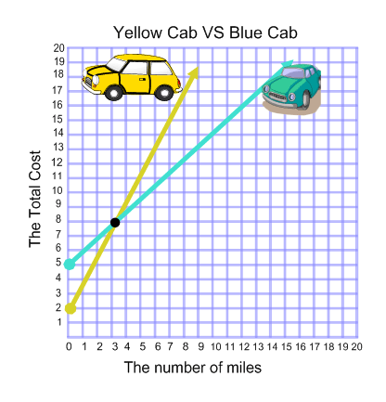

**Sample Problem:**

The Yellow Cab company charges $2 plus an additional $3 for every 2 miles traveled. The Blue Cab company charges $5 plus $1 for every mile traveled. If you travel 2 miles, which company has the better rate? 3 miles? 10 miles?

|  |
| --- |
|  |
| Additional Support:  * Check the teacher web page and Canvas page for notes, activities, and assignments. * Search the topic on the web. We recommend using Khan Academy. * Attend tutorials. |

We will…

* solve linear systems of equations with two and three variables by graphing, substitution and elimination.
* formulate systems of equations of real-world situations with two and three variables.
* add, subtract, multiply by a scalar, and multiply matrices with and without technology.
* solve linear systems of equations with two and three variables by matrices.

|  |
| --- |
|  |
| Why do we study this?   * Many decisions we make in our everyday financial lives can be captured as a system of equations. * Systems of equations can be used to find a break-even point and to determine the better deal. |
|  |

|  |  |
| --- | --- |
| Formative Assessments | Summative Assessments |
| Ongoing formative assessments during lesson and homework activities will help in monitoring learning and providing feedback for students. | Summative assessments to measure learning at the end of concepts will include the following:   * Test: Solving Systems by Graphing, Substitution, and Elimination * Test: Solving Systems with 3 variables * Test: Formulating Systems * Unit 2 Exam (district-wide) |

How we will show what we have learned…